Transmittal Memorandum

To: Arlene Chumley, President, Board of Directors
From: Kimberly Tyler, Resident of Townes at Kettle Creek
Date: October 1, 2016
Subject: Installing a Playground in the Community

The residents of Townes at Kettle Creek have requested a playground area be installed in the community. The residents have complained about the lack of a playground area and the safety of children playing in the parking areas and streets. This report gives recommendations for increasing safety in the neighborhood and the benefits of building a playground. It includes both primary and secondary research. The purpose is to get the Board of Directors of the Homeowners Association (HOA) approval on building a new playground within the townhouse community.

A playground area provides many benefits. When children play, they learn skills that help them to develop physically, socially, and emotionally. I think it is important that children in the townhouse community not be deprived of these developmental opportunities due to the lack of a safe play area. Recommendations for increasing safety in the neighborhood include asking the Board of Directors of the HOA for approval to build a playground and forming a residential Playground Project Team to help design the playground and raise money.

My research shows that building a playground in Townes at Kettle Creek will be beneficial to the children, adults, and the community. Installing a playground will decrease safety concerns with children playing in the streets and parking areas. Additionally, it will help bring the community together by providing a central area to sit around and talk. I hope the concern for safety without a playground area is considered and we can work on taking the next step in this proposal.

Executive Summary

Purpose and method of this report

The governing documents of the Homeowners Association for the Townes at Kettle Creek residence does not allow children to play or recreate in the parking areas, fire lanes, streets and driveways due to safety reasons. However, there is no safe play area provided. The residents in Townes at Kettle Creek have requested a playground area be installed in the community. The purposes of this report are to:
- Examine the benefits of a playground area
- Recommend ways of funding the installation of a playground area

I conducted primary research by interviewing a few of the residents with children in the townhouse community to see if they agree with the idea of a playground area being built. A review of scholarly literature on playgrounds is provided to show the benefits this community would receive by building a playground area.

Findings and conclusion

Many of the residents that were interviewed recognized the importance of building a playground area and stated that they were in agreement of an area being created for the children. Research shows that building a playground in Townes at Kettle Creek will:
- Improve social interactions of adults and children
- Allow children to be more physically active and potentially avoid obesity
- Help children gain physical, developmental, psychological, and health benefits
- Increase home values

Recommendations for installing a playground

Recommendations for installing a playground include:
- Conduct research to see if this is a good investment, find a good location for a playground, and donate funds.
- Create a Playground Project Team to help design the playground, raise money, choose the location, and handle maintenance.
- Request local business owners to show community support by contributing.

Table of Contents
1 Introduction 1
1.1 Objectives 1
1.2 Findings and Discussion 1
2 Safety Hazards in the Neighborhood 1
2.1 Benefits of Playground Areas on Social Interaction in Communities 2
2.2 Benefits of Exercise for Young Children 3
2.3 Effects of Playground Areas on Home Values 3
3 Conclusions 4
4 Next Steps 5
References 6

1 Introduction

Physical inactivity among children is a growing concern as neighborhoods become more urbanized, lack the access to parks or open spaces, or do not have a decent perception of safety. The non-existence of playgrounds in some areas can be associated with the rise of childhood obesity. The lack of a playground also has an effect on social interactions amongst the children in the community as well as the adults. Studies have been conducted on the association between neighborhood playgrounds and its impact on children’s physical activity levels.

The lack of having a playground area in the townhouse community has become a problem as more children are moving into the area. Children like to play outside, but this community is mostly car-oriented and has only a designated green area for dogs to use. According to the governing documents of the Homeowners Association, playing or recreating in the parking areas, fire lanes, streets and driveways is strictly prohibited for obvious safety reasons. Because of these restrictions, there is no safe area where children can participate in outdoor activities.

1.1 Objectives

The residents of Townes at Kettle Creek have requested a playground area be installed in the community. It has come to the attention of the residents that the neighborhood is lacking a safe environment for children and is in need of a safe play area. This report will provide readers with key knowledge on the benefits of playground areas as well as give recommendations on how to implement one within the community.

1.2 Findings and Discussion

The findings of this report will be presented in four sections:
- Safety hazards in the neighborhood
- Benefits of playground areas on social interaction in communities
- Benefits of exercise for young children
- Effects of playground areas on home values

2 Safety Hazards in the Neighborhood

I have interviewed a few of the residents with children in the townhouse community that agree with the idea of a playground area being built. These residents feel as though a playground area would provide the children a safe place to play and keep them from being in violation of the governing documents of the Homeowners Association. I personally received a letter in the mail from the property manager on behalf of the Association that was addressed to my landlord. The letter stated, “Please inform your tenants to refrain from recreating or playing in the parking areas or fire lanes due to safety hazards. This helps keep the community aesthetically pleasing and more enjoyable for all of the residents” (D. Burns, personal communication, September 13, 2016). I don’t think it is fair that I am being told my children are not allowed to play in the streets when there are no other options provided for them to play. After receiving this letter, I spoke with a couple who live down the street from me whose children also play in the street. Mrs. Robertson stated, “We haven’t received a letter yet but it’s not fair that our children do not have a safe area to play out here. We wouldn’t have picked this place to live if we knew that our kids weren’t allowed to play outside” (personal communication, September 14, 2016). If I would have known of these limitations in this neighborhood, I too wouldn’t have picked this neighborhood to live in either. I also spoke with my son’s best friend’s mother. According to Mrs. Colton, “I really like this neighborhood but I need my son to be able to play outside in a safe location. Currently he rides his bike and plays around in the streets but where else is there for him to go?” (personal communication, September 14, 2016).

2.1 Benefits of Playground Areas on Social Interaction in Communities

Studies show that adults and children can benefit from community playgrounds. One main benefit is social interaction. Playgrounds are designed mainly for the interaction of children to improve their mental and physical health through play and social interaction (Pelle, n.d.). It also provides adults “an opportunity to meet other families for play-dates” (Pelle, n.d). Neighbors who live in a “walkable, mixed-use neighborhood” are more likely to socialize and get to know their neighbors whether it be intentional or accidental (Leyden, 2013). Interactions such as these build a sense of familiarity, safety, trust, and assist with future engagements within the community (Leyden, 2013). However, Leyden noted, American neighborhoods are becoming significantly “car-oriented”, thus creating a negative effect on social interaction (p. 1550). The Townes at Kettle Creek as shown in Figure 1, is very car-oriented and doesn’t allow children adequate space to participate in physical activity.

Bennet, Yiannakoulias, Williams, and Kitchen (2012) studied parental social interaction which resulted in the opposite of their hypothesis that “parents with better playground access are more likely to engage in social activities” (p. 207). Though playgrounds within close proximity show positive residential interaction, neighbors who have to travel farther are also more likely to be “socially engaged” (p. 210). Furthermore, the farther a family travels to the playground, the more likely they will stay for a longer period of time, increasing the chance of social interaction (p. 210). There are newly developed houses being built directly across the street from Townes at Kettle Creek and these families do not have a playground area in the neighborhood either. If a playground was built in our community, those residents would travel to visit and bring more social interaction with communities outside our immediate community.
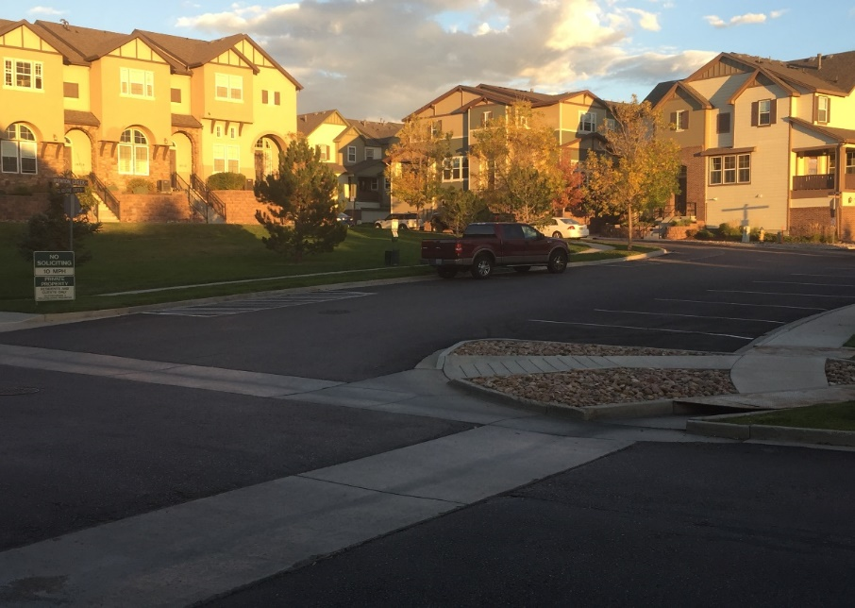
Figure 1. Townes at Kettle Creek parking area

2.2 Benefits of Exercise for Young Children

There is substantial research showing the link between exercise and brain development, motor-skills, and social capabilities. Studies show children who are physically active perform better academically, therefore resulting in decreased delinquency and behavioral issues (Reid & Bolen, 2014). Bennet et al. (2012) also found that “play is critical for the intellectual and physical development of children” (p. 201). Children who are physically active more frequently gain health benefits that are both physical and psychological, such as “increased cardiorespiratory fitness and muscular strength, reduced body fatness, favorable cardio-metabolic disease risk profiles, improved self-esteem, and fewer depressive symptoms” (Boonzajer Flaes, Chinapaw, Koolhaas, van Mechelen, Verhagen, 2016). The physical environment also has a great influence on the intensity of exercise a child is able to participate in. Not only do children require activity within their neighborhood, but also they need to be taught physical education in school at all grade levels.

Childhood obesity is caused by multiple factors. Physical activity is widely recognized as a significant contributor in the prevention of obesity. At younger ages, children are more at risk for becoming obese or having possible health issues. According to Dugan (2008), “obese children are at increased risk of acute medical illnesses and chronic diseases”. Physical activity has a positive effect on obesity and it also delays osteoporosis (Rowland & Freedson, 1994).

2.3 Effects of Playground Areas on Home Values

The positive effects of having a playground and other amenities would lead to the conclusion that every neighborhood where families with children predominantly reside would benefit. People are starting to become more health conscious and participating in more recreational activities such as walking, jogging, and cycling (Asabere & Huffman, 2009). Neighborhoods that provide these extra amenities are more likely to gain more residents in which the owner will be able to increase the cost of their homes.

The literature suggests that playgrounds and other amenities significantly add to a homes value. A study conducted by Asabere & Huffman (2009), showed the following amenities add to a homes value: proximity to golf course, neighborhood playground, tennis court, neighborhood pool, view, and a cul-de-sac (p. 417). The National Association of Realtors survey (as cited in Proud, 2015), found that “50 percent of home buyers were prepared to pay 10 percent more for the same house if located near a park”. Not only do homeowners value parks, but businesses are also willing to invest in developing properties near parks as well (Proud, 2015). In Pittsburgh, the property values in the area around the Three Rivers Park increased by nearly 60 percent over 15 years compared with 32 percent in the rest of the city (Proud, 2015). People looking to sell a home within the vicinity of a park and other amenities are more likely to get a better offer than those without.

3 Conclusions

Green spaces provide a physically and socially fit atmosphere that gives children and adults a sense of safety that brings the community together. Now even businesses are starting to recognize that owning a property near a park would prove to be beneficial in the long run (Proud, 2015). Playgrounds and other green areas are starting to be recognized as an important role in the American society. By building a playground for the townhouse community and the residents who live here, we will gain many benefits such as providing safety, keeping children physically fit, and potentially increasing the home value.

It is strongly recommended that the Board of Directors of the Homeowners Association approve a playground to be built in the community. The townhouse community residents could come together in support of having a playground area created for the children and form a Playground Project Team. The team could help design the playground, raise money, chose the location, and handle maintenance. A recommendation for the location of where the playground can be placed is the empty pond area in the front of the neighborhood as shown in Figure 2.

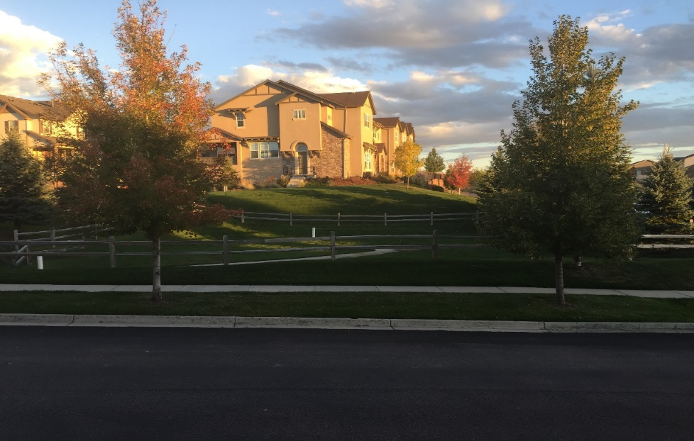
Figure 2. Townes at Kettle Creek Pond/Open Area

4 Next Steps

Based on the findings, these are the recommended next steps.

- The Board of Directors can conduct their own research to see if building a playground is a good investment and where is a good location.

- The Board of Directors can donate funds if building a playground is approved.

- Townhouse community residents will create a Playground Project Team to find a playground design, set a budget, and raise money. For a good reference, the team can look at the National Recreation and Park Association website to find different manufacturers and designs.

- Once a budget is set, fundraising can begin by having a neighborhood party with private donations or asking local businesses to show community support by contributing. Contractors and equipment companies may be willing to donate as well.

- Build the playground and find a company that will conduct regular maintenance.

References

Asabere, P., & Huffman, F. (2009). The relative impacts of trails and greenbelts on home price. Journal Of Real Estate Finance & Economics, 38(4), 408. doi:10.1007/s11146-007-9089-8

Bennet, S. A., Yiannakoulias, N., Williams, A. M., & Kitchen, P. (2012). Playground accessibility and neighbourhood social interaction among parents. Social Indicators Research, 108(2), 199-213. doi:10.1007/s11205-012-0062-4

Boonzajer Flaes, S. A., Chinapaw, M. J., Koolhaas, C. M., van Mechelen, W., & Verhagen, E. A. (2016). More children more active: Tailored playgrounds positively affect physical activity levels amongst youth. Journal Of Science & Medicine In Sport, 19(3), 250. doi:10.1016/j.jsams.2015.03.001

Dugan, S. A. (2008). Exercise for preventing childhood obesity. Physical Medicine & Rehabilitation Clinics Of North America, 19(The Child and Adolescent Athlete), 205-216. doi:10.1016/j.pmr.2007.11.001

Leyden, K. M. (2003). Social capital and the built environment: The importance of walkable neighborhoods. American Journal of Public Health, 93(9), 1546–1551. doi: 10.2105/AJPH.93.9.1546

Pelle, F. (n.d.). How playgrounds improve the community | Decatur Parks & Recreation. Retrieved from http://www.decaturparks.com/how-playgrounds-improve-the-community.php

Proud, I. (2015, May 29). Play and playground news center. Retrieved from http://www.playgroundprofessionals.com/news/parks-and-recreation/parks-real-estate-increasing-value106

Reid, J., & Bolen, Y. (2014). The prevalence of obesity: The need for quality school physical education. Review Of Higher Education & Self-Learning, 7(24), 95-100. Retrieved from http://www.intellectbase.org/RHESL.php

Rowland, T. W., & Freedson, P. S. (1994). Physical activity, fitness, and health in children: a close look. Pediatrics, (4), 669.

